**Arithmetic Calculator Screenshots:-**

**GitHub Reciprocity Link**:- https://github.com/kapildavey/Phase1.git

**Screenshot Of Addition Operation:-**

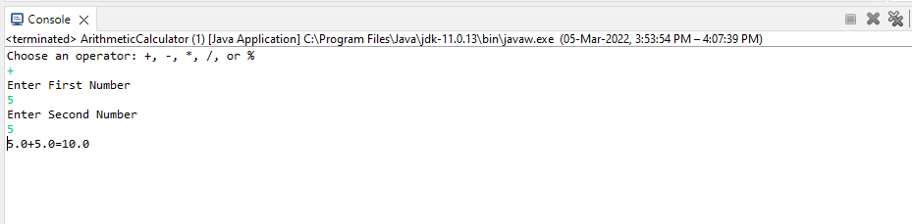

**Screenshot Of Subtraction Operation:-**

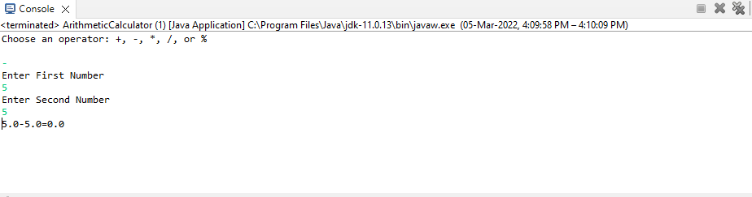

**Screenshot Of Multiplication Operation:-**

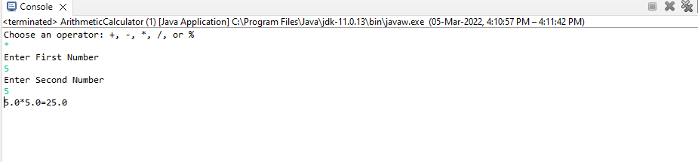

**Screenshot Of Division Operation:-**

